Vocation Sunday KS2 Resource

John 10:22-30
Then came the Festival of Dedication^{[a]} at Jerusalem. It was winter, and Jesus was in the temple courts walking in Solomon’s Colonnade. The Jews who were there gathered around him, saying, “How long will you keep us in suspense? If you are the Messiah, tell us plainly.” Jesus answered, “I did tell you, but you do not believe. The works I do in my Father’s name testify about me, but you do not believe because you are not my sheep. My sheep listen to my voice; I know them, and they follow me. I give them eternal life, and they shall never perish; no one will snatch them out of my hand. My Father, who has given them to me, is greater than all; no one can snatch them out of my Father’s hand. I and the Father are one.” 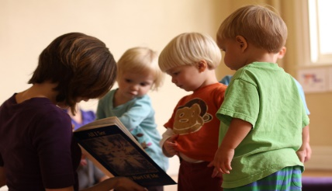
Tell the story of the Good Shepherd. Explore who are the sheep, who is the shepherd. Are the sheep all the same? Are people all the same? What are you good at, what are your gifts? How can you use them for God?
This Photo by Unknown Author is licensed under CC BY-ND
Discuss with children:
Who cares for, loves and guides us in our daily lives? (parents, teachers, doctors etc). Who is the shepherd in your church? ( Vicar etc) Who else has special jobs in the church ( Sunday School leaders, churchwardens etc) What job could you do in the church? ( server, help with the book collection, read a lesson etc)
Make a poster about helping in the church

Sing The Lord’s my Shepherd
Prayer : Lord Jesus, you are our Shepherd and we are your sheep, help us to follow you in all that we do. We want to listen carefully to your voice and understand our special task in the world. Amen

Acknowledgement – some used from Diocese of Llandaff

