Vocation Sunday KS1 Resource

John 10:22-30
Then came the Festival of Dedication^{[a]} at Jerusalem. It was winter, and Jesus was in the temple courts walking in Solomon’s Colonnade. The Jews who were there gathered around him, saying, “How long will you keep us in suspense? If you are the Messiah, tell us plainly.” Jesus answered, “I did tell you, but you do not believe. The works I do in my Father’s name testify about me, but you do not believe because you are not my sheep. My sheep listen to my voice; I know them, and they follow me. I give them eternal life, and they shall never perish; no one will snatch them out of my hand. My Father, who has given them to me, is greater than all; no one can snatch them out of my Father’s hand. I and the Father are one.” 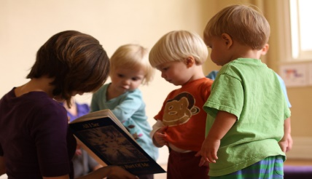
This Photo by Unknown Author is licensed under CC BY-ND
Talk about sheep, how they follow one another, how the shepherd knows each one. Tell Jesus’ story about the Lost Sheep. Act out the story with a game of hide and seek, the one hiding represents the lost sheep. Explain that shepherds know their sheep so well they know when one is missing. In the same way Jesus searches for us when we lose our way from him. Jesus is the Good Shepherd, he looks after all of us. Introduce the idea that we can all look after one another.
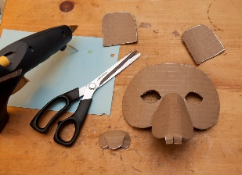
Make a sheep mask by sticking cotton wool to the mask face
This Photo by Unknown Author is licensed under CC BY-ND
Sing The Lord’s my Shepherd
Prayer : Lord Jesus, you are our Shepherd and we are your sheep, help us to follow you in all that we do. We want to listen carefully to your voice and understand our special task in the world. Amen Acknowledgement – some used from Llandaff Diocese

