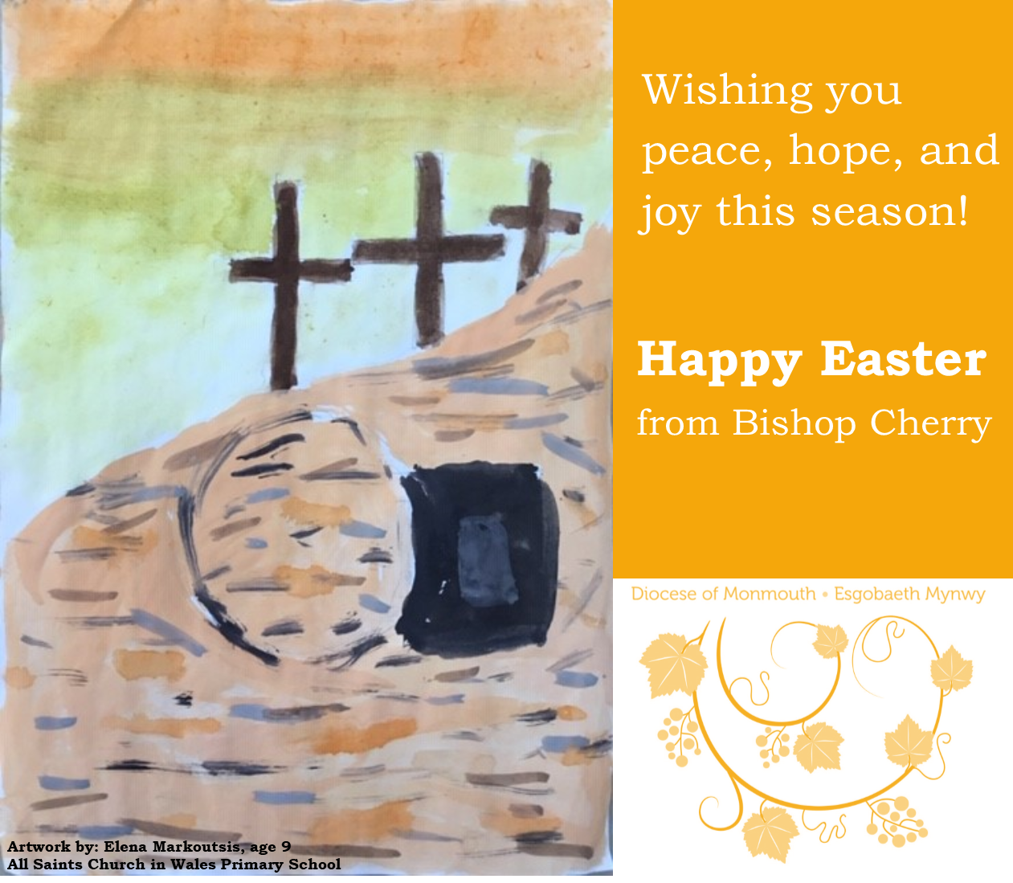

Alleluia, Christ is risen!
He is risen indeed. Alleluia!

That confident statement of faith echoes down the centuries to our present-day circumstances. We might remember that the assertion of Christ’s resurrection and triumph over evil and death has held people in and through the darkest of times; be that the horrors of war, the degradation of persecution or the many other plagues and pandemics that have ravaged humanity in the past. It has also held individuals through personal tragedy and suffering beyond what most of us can imagine.
What resurrection means for us is something that we grapple with at the best of times. Today, we are living through a world-wide challenge that raises the profoundest of questions, not least for people of faith who proclaim the good news of God’s love and resurrection life through Jesus.

To say that this is a mystery may sound trite, but it is true, nonetheless. And those of us who have responded to Jesus’s call to ‘follow me’, can respond to the mystery of Christ’s death and resurrection only in faith and trust.
As we enter into Holy Week, knowing (as those first disciples certainly did not) that the agony of Good Friday is the gateway into Easter Day, let us seek to embrace the mystery of the resurrection with the gift of faith that God has given to us and proclaim confidently, with our sisters and brothers across the world:

Christ is risen! He is risen indeed, Alleluia!

Wishing you a joyful and blessed Easter,

