A Service of Commemoration
of Her Late Majesty
Queen Elizabeth II

Gwasanaeth Coffadwriaeth
i’r Ddiweddar Fawrhydi
Y Frenhines Elizabeth II

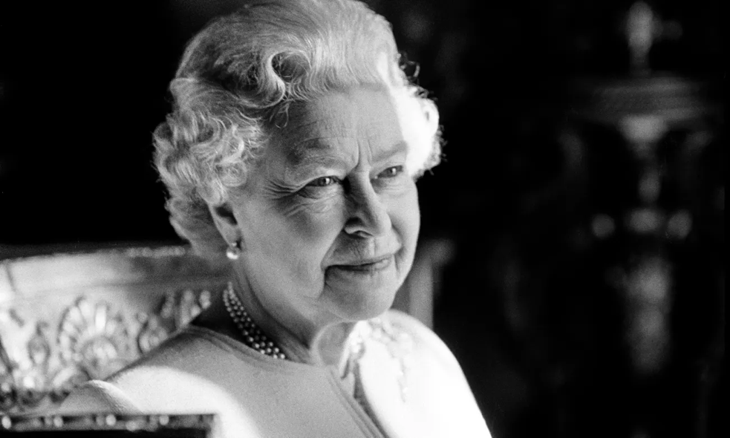

Sunday, 18th September 2022, 4.00pm
Dydd Sul, 18 Medi, 2022, 4.00pm
Welcome to Newport Cathedral.
Croeso i Gadeirlan Casnewydd.

As we prepare for the funeral of Her Late Majesty Queen Elizabeth II, we remember with great thanksgiving her years of dedicated service to her realm, we pray for her and all who mourn her.

This service includes material prepared for use specially at this time. The Bishops of the Church in Wales are grateful to the Church of England and Cambridge University Press for granting permission to adapt the forms approved by the Archbishops of Canterbury and York for use in their provinces.

STAND / SEFYLL
Hymn / Emyn: All my hope on God is founded

1 All my hope on God is founded;
he doth still my trust renew,
me through change and chance he guideth,
only good and only true.
God unknown, he alone
calls my heart to be his own.

2 Human pride and earthly glory,
sword and crown betray his trust;
what with care and toil he buildeth,
tower and temple fall to dust.
But God's power, hour by hour,
is my temple and my tower.

3 God's great goodness aye endureth,
deep his wisdom, passing thought:
splendour, light and life attend him,
beauty springeth out of naught.
Evermore from his store
newborn worlds rise and adore.

4 Daily doth the almighty Giver
bounteous gifts on us bestow;
his desire our soul delighteth,
pleasure leads us where we go.
Love doth stand at his hand;
joy doth wait on his command.

5 Still from earth to God eternal
sacrifice of praise be done,
high above all praises praising
for the gift of Christ, his Son.
Christ doth call one and all:
ye who follow shall not fall.

Words: J. Neander trans. Robert Bridges
Introduction – The Dean

Sentence of Scripture and Introduction

The eternal God is your refuge:
and underneath are the everlasting arms.
Deuteronomy 33:27

I am convinced that neither death, nor life,
nor angels, nor rulers,
nor things present, nor things to come,
nor powers, nor height, nor depth,
nor anything else in all creation,
will be able to separate us from the love of God
in Christ Jesus our Lord.
Romans 8:38, 39

In the name of Christ,
who died and was raised
to the glory of God the Father,
grace, mercy and peace be with you.

We meet to remember before God
our late Sovereign Lady Queen Elizabeth,
to renew our trust and confidence in Christ,
and to pray that together we may be one in him,
through whom we offer our prayers and praises to the Father.

O God, make speed to save us.
All: O Lord, make haste to help us.

Blessed are you, Lord our God, lover of souls:
you uphold us in life and sustain us in death:
to you be glory and praise for ever!
For the darkness of this age is passing away
as Christ, the bright and morning star,
brings to his saints the light of life.

As you give light to those in darkness,
who walk in the shadow of death,
so remember in your Kingdom
your faithful servant, Elizabeth,
that death may be for her the gate to life
and to unending fellowship with you;
where with your saints you live and reign,
one in the perfect union of love,
now and for ever.
All: Amen.

SIT / EISTEDD
Tribute – Mubarak Ali
Secretary of the Islamic Society for Wales

The Psalm / Y Salm – 121
Sung by the choir

1 I will lift up mine eyes unto the hills:
from whence cometh my help?

2 My help cometh from the Lord:
who hath made heaven and earth.

3 He will not suffer thy foot to be moved:
and he that keepeth thee will not sleep.

4 Behold he that keepeth Israel:
shall neither slumber nor sleep.

5 The Lord himself is thy keeper:
the Lord upon thy right hand shall give thee shade;

6 The sun shall not strike thee by day:
neither shall the moon by night.

7 The Lord shall preserve thee from all evil:
yea it is he that shall keep thee safe.
8 The Lord shall preserve thy going out and thy coming in:
from this time forth for evermore.

Stand for the Gloria

Glory be to the Father, and to the Son:
and to the Holy Spirit;
As it was in the beginning, is now,
and ever shall be: world without end. Amen.

SIT / EISTEDD

Bible Reading / Darlleniad o'r Beibl –
1 Corinthians / 1 Corinthiaid 15:1, 3-4, 35-38, 42, 57-58
Read by Brigadier Robert Aitken CBE, His Majesty’s Lord Lieutenant of Gwent

Now I should remind you, brothers and sisters, of the good news that I proclaimed to you, which you in turn received, in which also you stand, ³ For I handed on to you as of first importance what I in turn had received: that Christ died for our sins in accordance with the scriptures, ⁴and that he was buried, and that he was raised on the third day in accordance with the scriptures.

³⁵ But someone will ask, ‘How are the dead raised? With what kind of body do they come?’ ³⁶What you sow does not come to life unless it dies. ³⁷And as for what you sow, you do not sow the body that is to be, but a bare seed, perhaps of wheat or of some other grain. ³⁸But God gives it a body as he has chosen, and to each kind of seed its own body.

⁴² So it is with the resurrection of the dead. What is sown is perishable, what is raised is imperishable. ⁵⁷But thanks be to God, who gives us the victory through our Lord Jesus Christ.

⁵⁸ Therefore, my beloved, be steadfast, immovable, always excelling in the work of the Lord, because you know that in the Lord your labour is not in vain.

For the word of the Lord.
All: Thanks be to God.

Anthem – In paradisium, from Requiem (Gabriel Fauré)

In paradisum deducant  Angeli:  in tuo adventu  suscipiant te Martyres,  et perducant te in  civitatem sanctam  Jerusalem.  Chorus Angelorum  te suscipiat,  et cum Lazaro  quondam paupere  aeternam habeas requiem. | May the angels lead you  to paradise:  at your coming  may the martyrs receive you,  and bring you into the  Holy City  Jerusalem.  May the choir of angels  receive you,  and with Lazarus,  once a beggar,  may you have eternal rest.

The Sermon / Y Bregeth – The Bishop

Prayers / Gweddiau

Let us pray.

Lord, have mercy upon us.
All: Christ, have mercy upon us.

Our Father,  who art in heaven,  hallowed be thy name,  thy kingdom come,  thy will be done,  on earth  as it is in heaven.  Give us this day  our daily bread.  And forgive us  our trespasses  as we forgive those  who trespass against us.  And lead us not  into temptation,  but deliver us from evil.  For thine is the kingdom,  the power and the glory,  for ever and ever. Amen. | Ein Tad,  yr hwn wyt yn y nefoedd,  sancteiddier dy enw,  deled dy deyrnas,  gwneler dy ewyllys;  megis yn y nef,  felly ar y ddaear hefyd.  Dyro i ni heddiw  ein bara beunyddiol  a maddau i  ni ein dyledion,  fel y maddeuwn  ninnau i’n dyledwyr.  Ac nac arwain  ni i brofedigaeth;  eithr gwared ni rhag drwg.  Canys eiddot ti yw’r deyrnas,  a’r gallu, a’r gogoniant,  yn oes oesoedd. Amen.

The souls of the righteous are in the hand of God :
All: And there shall no torment touch them. Wisdom of Solomon 3:1

You, Lord, have delivered my soul from death :
All: My eyes from tears and my feet from falling. Psalm 56:13

I will walk before the Lord :
All: In the land of the living. Psalm 116:9

Merciful Father and Lord of all life,
we praise you that we are made in your image
and reflect your truth and light.
We thank you for the life
of our late Sovereign Lady Queen Elizabeth,
for the love she received from you
and showed among us.
Above all, we rejoice at your gracious promise
to all your servants, living and departed,
that we shall rise again at the coming of Christ.
And we ask that in due time we may share
with your servant Elizabeth
that clearer vision promised to us
in the same Christ our Lord.
All: Amen.
Almighty God,
Father of all mercies and giver of all comfort:
deal graciously, we pray, with all who mourn,
the members of the Royal Family,
this Nation and all the Nations of the Commonwealth,
that casting all our care on you,
we may know the consolation of your love;
through Jesus Christ our Lord.
All: Amen.

Bring us, O Lord God, at our last awakening
into the house and gate of heaven,
to enter into that gate and dwell in that house,
where there shall be no darkness nor dazzling,
but one equal light;
no noise nor silence,
but one equal music;
no fears nor hopes,
but one equal possession;
no ends nor beginnings,
but one equal eternity;
in the habitations of thy glory and dominion,
world without end.
All: Amen.
after John Donne (1571–1631)

Remember, O Lord,
what thou hast wrought in us,
and not what we deserve;
and as thou hast called us to thy service,
make us worthy of our calling;
through Jesus Christ our Lord.
All: Amen.

Merciful God,
you have prepared for those who love you
such good things as pass our understanding:
pour into our hearts such love toward you
that we, loving you in all things
and above all things,
may obtain your promises,
which exceed all that we can desire;
through Jesus Christ your Son our Lord,
who is alive and reigns with you,
in the unity of the Holy Spirit,
one God,
now and for ever.
All: Amen.

STAND / SEFYLL

Commendation / Cyflwyno – The Bishop

Let us commend our late Sovereign Lady Queen Elizabeth
into the hands of God, our maker and redeemer.

Silence is kept.

God our creator and redeemer,
by your power Christ conquered death
and entered into glory.
Confident of his victory and claiming his promises,
we entrust our late Sovereign Lady Queen Elizabeth
to your mercy;
in the name of Jesus our Lord,
who died and is alive
and reigns with you,
now and for ever.
All: Amen.

The choir sings the Orthodox Kontakion for the Departed

Give rest, O Christ, to your servant with the saints:
where pain and sorrow and grief are no more,
but life everlasting.
You alone are the immortal one,
the creator and maker of us all.
We are mortals:
from earth we were fashioned,
to earth we shall return;
for so you ordained when you made me, saying:
“dust you are, and unto dust you shall return”.
All we go down to the dust;
yet even over the grave we make our song:
Alleluia, Alleluia, Alleluia.

Grant, Lord,
that we may live in your fear,
die in your favour,
rest in your peace,
rise in your power
and reign in your glory;
for your own beloved Son’s sake,
Jesus Christ our Lord.
Amen.
William Laud (1573–1645)

Eternal rest grant unto her, O Lord,
All: And let perpetual light shine upon her.

Go in peace to love and serve the Lord.
All: In the name of Christ. Amen.

May God's help remain with us
and may our departed brothers and sisters in the Lord
rest in peace,
All: And rise in glory. Amen.

Hymn / Emyn: O God, our help in ages past

1 O God, our help in ages past,
Our hope for years to come,
Our shelter from the stormy blast,
And our eternal home;

2 Beneath the shadow of thy throne
Thy saints have dwelt secure;
Sufficient is thine arm alone,
And our defence is sure.

3 Before the hills in order stood,
Or earth received her frame,
From everlasting thou art God,
To endless years the same.

4 A thousand ages in thy sight
Are like an evening gone;
Short as the watch that ends the night
Before the rising sun.

5 Time, like an ever-rolling stream,
Bears all its sons away;
They fly forgotten, as a dream
Dies at the opening day.

6 O God, our help in ages past,
Our hope for years to come,
Be thou our guard while troubles last,
And our eternal home.
Isaac Watts (1674–1748)

Concluding Prayer / Gweddi Terfynol

Almighty God, the fountain of all goodness,
bless our Sovereign Lord King Charles III
and all who are set in authority under him,
that they may order all things in wisdom and equity,
righteousness and peace,
to the honour of thy holy Name
and the good of thy Church and people;
through Jesus Christ our Lord.
All: Amen.

The Blessing / Y Fendith

May God in his infinite love and mercy
bring the whole Church,
living and departed in the Lord Jesus,
to a joyful resurrection
and the fulfilment of his eternal kingdom;
And the blessing A bendith
of God Almighty, Duw hollalluog,
+ the Father, the Son, + y Tad, y Mab,
and the Holy Spirit a’r Ysbryd Glân
be among you a fo yn eich plith
and remain with you ac a drigo gyda chwi
always. yn wastad.
All: Amen. Amen.

The National Anthems

God save our gracious King,
Long live our noble King,
God save the King.
Send him victorious,
Happy and glorious,
Long to reign over us:
God save the King.

Thy choicest gifts in store
On him be pleased to pour,
Long may he reign.
May he defend our laws,
And ever give us cause,
To sing with heart and voice,
God save the King.

Mae hen wlad fy nhadau yn annwyl i mi,
Gwlad beirdd a chantorion, enwogion o fri;
Ei gwrol ryfelwyr, gwladgarwyr tra mâd,
Tros ryddid gollasant eu gwaed.

Gwlad, Gwlad, pleidiol wyf i'm gwlad,
Tra môr yn fur i'r bur hoff bau,
O bydded i'r heniaith barhau.

English translation
This land of my fathers is dear to me
Land of poets and singers, and people of stature
her brave warriors, fine patriots
shed their blood for freedom

Land! Land! I am true to my land!
As long as the sea serves as a wall for this pure,
dear land may the language endure for ever.

Voluntary: Andante Espressivo, movement 3 from Organ Sonata in G major, Op. 28 - Edward Elgar

There is no physical collection during this service.
Ni fydd casgliad yn ystod y gwasanaeth hwn.

You can make a donation to support the Cathedral’s mission and ministry in the following ways:

Gallwch gyfrannu at genhadaeth a gweinidogaeth y Gadeirlan yn y ffyrdd canlynol:

Cash donations can be placed in the collection plates
in the St Mary Chapel

Rhoi arian parod yn y platiau casgliad yng Nghapel Santes Fair

Using the contactless donation point by the door

Defnyddio’r teclyn talu’n ddi-gyswllt wrth y drws

Online through the link on the Cathedral website.

Arlein drwy’r linc ar wefan y Gadeirlan

www.newportcathedral.org.uk

CCLI Church Copyright Licence: 1438728

NOTE

The liturgical forms given here include texts from existing sections of the Book of Common Prayer for use in the Church in Wales, namely An Order for the Holy Eucharist © Church in Wales Publications and the Representative Body of the Church in Wales 2004, 1984; Daily Prayer © Church in Wales Publications and the Representative Body of the Church in Wales 2010; and Funeral Services © The Representative Body of the Church in Wales 2020. Except where otherwise stated, references to the psalms are to the Church in Wales’ Daily Prayer Psalter.

