DIOCESE OF MONMOUTH

**HEART OF MONMOUTHSHIRE   
MINISTRY AREA**

TEAM VICAR POST

DIOCESE OF MONMOUTH   
**Introduction from the Archdeacon of Monmouth,   
The Venerable Ian Rees**

Thank you for taking the time to look at this profile. We are seeking to appoint a Team Vicar for the Heart of Monmouthshire Ministry Area based in the beautiful village of Goetre.

This post will be part of a Ministry Team serving a new Ministry Area. It offers an exciting opportunity to work collaboratively with lay and ordained colleagues.

The churches where you will primarily be based have worked together for a number of years and we imagine that the close relationship between them will continue whilst they also become active participants in the wider Ministry Area.

The Ministry Area is very well served currently by a Rector/Ministry Area Leader, a Team Vicar and a Team Curate, as well as other retired priests with permission to officiate and lay ministers. We are looking to build and extend collaborative teams that will foster and develop the work already happening in this beautiful part of rural Monmouthshire.

The area has some magnificent buildings and a rich social history which makes this a very attractive place to minister and live. It is an area of great potential and there is a passion within the congregations here to proclaim the Good News in these communities. The people are warm, welcoming, and have a genuine desire to grow the Kingdom of God.

For an informal conversation or further information please contact the Ministry Area Leader, The Rev’d Kevin Hasler on 078 3679 5753 or [kevinhasler@cinw.org.uk](mailto:kevinhasler@cinw.org.uk).

With my best wishes

**Ian Rees**Archdeacon of Monmouth

**We are looking for a Priest who will be:**

* Caring - has a strong pastoral heart and passion for encouraging the members of each of the congregations in discipleship.
* Collaborative in nature - working well with the Ministry Team, lay and ordained, within the Ministry Area and is a good team player
* Committed to and understanding of the special nature of rural ministry with a desire to serve these communities and farming networks.
* Creative and imaginative in their approach to working with children, young people and families in schools and across the Ministry Area.

Based in the lovely village of Goetre and primarily working with churches around that area, you will also be part of the Ministry Team covering the Heart of Monmouthshire Ministry Area which has 20 church buildings and distinct communities.

For an informal conversation please contact:   
The Rev’d. Kevin Hasler, Rector and Ministry Area Leader on 078 3679 5753.

**Our new Team Vicar**

We seek a prayerful pastor of spiritual maturity to minister to the churches and closely knit rural communities of this beautiful part of the Heart of Monmouthshire Ministry Area.

As the name suggests we cover some 20 church buildings across the centre of this historic county with some 20 church buildings, encompassing two significant villages and an ancient town as well as numerous smaller dispersed hamlets and farmsteads. The Ministry Area is co-terminus with the Raglan and Usk Deanery and the Rector is also Rural Dean.

Our Ministry Area stretches from just south of Abergavenny down the Usk Valley to just north of Newport, reaching to Llandegfedd (and the reservoir) in the West and Wolvesnewton (and the fringes of Wentwood) in the East.

Both the Usk Showground and the Monmouthshire Livestock Market are in our area and we have keen ministries to both. So, a mature understanding and a passion for the special nature and needs of rural ministry and the ability to guide and develop these are essential, together with a willingness to engage with the wider Ministry Area.

You will be centred around five church communities and fulfil a wider role across the Ministry Area in building, guiding and nurturing our work with schools, children, young people and families.

As such you would also be expected work alongside the Team Rector, another Team Vicar, a Team Curate, a Lay Reader and lay and clerical colleagues (including a small number of retired priests with permission to officiate).

Our aim is for each church to retain its local identity by having a 'focal minister' who may be ordained or lay, and we are developing a model whereby half of the stipendiary clergy time is given to Ministry Area-wide responsibilities with the other half for local initiatives and pastoral care and support to those specific communities that look to each cleric for ongoing ministry.

You will be a key member of the Ministry Team for the wider Ministry Area and an ex-officio member of the Ministry Area Council (PCC) and will be expected to share in presiding across the Ministry Area.

**Locality**

You will be the named priest for five worshipping communities in the North-West part of the Ministry Area covering Llanover, Goetre, Mamhilad, Monkswood and Glascoed.

Churches covered by this role

The A4042 provides excellent road links to Abergavenny and the Heads of the Valley Road whilst travelling South through the town of Cwmbran takes you to the M4 motorway with links into South Wales and England. Train services are from Abergavenny and New Inn/Pontypool with connections to the UK rail network.

We feel strongly that ministering to a rural community is different from serving in an urban area. Many in the community see the church as their church, even if they only attend on ‘high days and holy days.’ Clergy, therefore, need to be an integral part of the community, and their ministry is to both the churched and non-churched in the community.

**The Communities**

**Llanover** is mostly owned by the local private estate. At one time the majority of the residents were employed by the estate, but now many of the properties are rented to tenants. Although some estate workers live in the village, jobs are hard to find locally, some of the tenancies are only short term so their involvement with the community is limited.

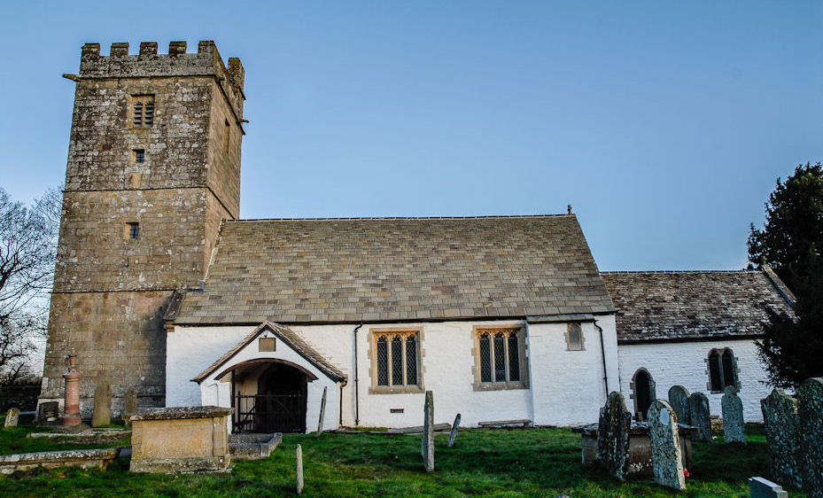There is a public house in upper Llanover, the Goose and Cuckoo. A thriving village hall, with a social club and many other activities, is situated in the centre of the village.

Llanover has a 15-acre garden and art pottery and is open to the public once a year with the National Garden Scheme. Members of St Bartholomew’s provide homemade cakes and tea for this event.

**Goetre** - from a small village of two or three hundred inhabitants in the 1950s Goetre has developed to its present size as a result of a substantial building programme with the majority of homes have been built in the last 50 years. The village has a public house, post office, shop, and doctors surgery, The modern village hall and social club is also the venue for our fortnightly Well-Being Café which is proving increasingly popular and supported by church members and the Hall Committee.

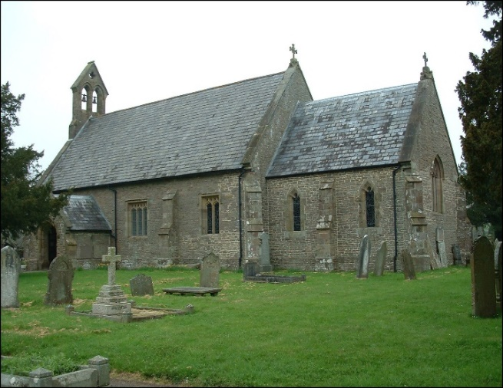Lack of local employment means that most residents commute outside the area. A large number of young families reside in the village and there is a good balance between the various age groups and secondary education is provided at King Henry VIII comprehensive school in Abergavenny and Caerleon comprehensive. Both schools have an excellent reputation.

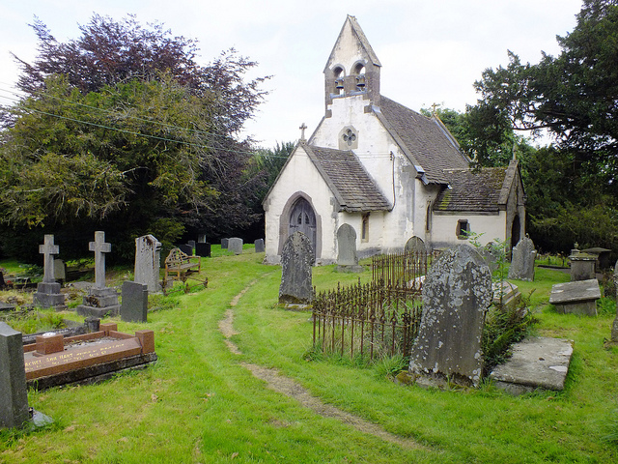**Mamhilad -** St Illtud’s Church is situated on the Old Abergavenny Road.  It is a small parish church with its origins in the 11th century.  Renovations took place in the 19th century and again in 2000 and is a Grade 11* listed building.  Opposite the church is The Star public house and just a short walk away is the Brecon and Monmouth canal.

The churchyard boasts eight yew trees which are a great source of interest to people visiting the church and were growing before the time of Jesus and have witnessed centuries of change in this quite corner of Monmouthshire,

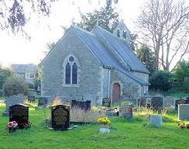

**MONKSWOOD** is a dispersed rural community stretching along the A472 and its many adjacent lanes in an area of rolling farmland and woodland. St Matthew’s church and the Glascoed pub are the only community buildings, so nearby Usk and Goytre provide the local facilities.

**GLASCOED** is sometimes synonymous with the former Royal Ordnance Factory, now BAE Systems which employs around 500 people, many from the local area. Glascoed village is a quiet residential area stretching towards Llandegfedd Reservoir and Woodlake Park Golf Club. The community has two places of worship: St Michael’s church and Zion Baptist Chapel. The Glascoed pub was the former ROF social club, and it now serves the wider community.

Since its foundation, Glascoed church has been the daughter church of Monkswood though the parish never had its own priest. It was served by Usk for many years, before being combined with Mamhilad and then the other churches in the area.

**The Rectory**

Was built in 1990 and is situated a few minutes walk from St Peter’s, Church Goetre. With four bedrooms, one with en-suite facilities, a family bathroom and a ground floor toilet and washbasin adjacent to a self-contained study, the house has a separate sitting room and dining room with sliding doors opening onto the rear garden.

The well-appointed kitchen is adjacent to a utility room with its own sink and access directly into the garden. There is a single detached garage with parking for 3-4 vehicles. Central heating is oil-fuelled with the tank and a septic tank being situated at the rear of the property. Surrounded by mature gardens the property is in a peaceful and quiet area overlooking fields and the distant Monmouthshire hills. Council Tax, water rates and expenses of Ministry will be paid in full.

**FOR MORE INFORMATION**

We are starting to build a new website at [homma.org](http://www.homma.org) and we have a presence on [Facebook](https://www.facebook.com/Heart-of-Monmouthshire-Ministry-Area-1041951092519455/).

To discuss the role or learn more about us please contact the Rector/Ministry Area Leader: Rev’d Kevin Hasler by email [kevinhasler@cinw.org](mailto:kevinhasler@cinw.org) or telephone 078 3679 5753.

Thank you for your interest in this exciting position.