Ministry Area profile

From the Archdeacon of Newport:

Thank you for taking the time to read the profile for this exciting post in the Tredegar Park Ministry Area.

The Diocese of Monmouth is restructuring into larger Ministry Areas to enable a collaborative sharing of resources and a greater focus on mission and outreach. Our hope is that this will enable the local churches to engage with their communities supported by the Ministry Team and the wider family of congregations. Nearly half of the Ministry Areas are now up and running and we anticipate the rest being formed by the end of 2022.

Tredegar Park Ministry Area covers the western side of the City of Newport. The demographic is very mixed from the post war estates in the south through to the suburbs in the north. There is much to do to rebuild the Church as we come out of the pandemic but there is a real desire to reconnect with people through both traditional and new forms of church as well as community projects. There is a true desire to work together to move things forward and create a new sense of purpose so that the Church can flourish once more.

If you have any questions about this post then please contact Revd Chris Stone. We look forward to receiving your application.

The Venerable Jonathan Williams
We are delighted that you have asked for a copy of this profile. In it we set out a description of our churches and our mission. We hope help you to discern if we are the right communities for you to join and help lead.
Our Purpose
Building a Community to reach a Community
Tredegar Park MA is passionate about living the Gospel message in Newport. We believe that God has called us into partnership with him to see the wider community transformed by God’s love. In this mission, we are committed to playing our part as:
A WELCOMING Community
- A church that seeks to be open and accessible to all, inviting everyone to experience God’s infinite love and welcome.
- A caring community in which the needs of others are recognised and acted upon.

A LIVING & LIVELY Community
- A community in which real life is shared, lived out and celebrated.
- Where life in all its fullness (John 10:10) is something we work towards together.
- Where worship is marked by a sense of God’s presence and life changing power.

A SHARING Community
- Where life, faith and hope are freely shared and lived out in our wider community.
- An outward looking, mission minded community that cares for the needs of others.
- A church that seeks to live out the gospel message of love, of freedom, of equality and of justice both locally and globally.
- A church where generosity flows in response to God’s generosity – where we are all encouraged to give as well as receive.

A GROWING Community
- A church with a desire to know God better, where there is a hunger to engage with the Bible and Sacraments, to grow in prayer and service.
- A community with a desire to learn with and from each other as fellow disciples of Jesus Christ.
- We desire to be a community growing spiritually and numerically, and growing in confidence
Location

The Ministry Area (MA) is made up of seven communities in Newport with a combined population of approximately 40,000 people. Transport links to Cardiff are very good and London is a two hour train ride from Newport station. Newport and Cardiff have great shopping, sporting and cultural amenities.

The Ministry Area itself has a number of local shops as well as supermarkets. There is a good choice of restaurants, pubs, takeaways, garages, vets, post offices and hairdressers.

South Wales is an area steeped in history. The Roman amphitheatre in Caerleon, Tredegar House, Castell Coch and Cardiff Castle are just a few places to mention.

Bassaleg and Rhiwderin are located two miles north west of Newport city centre. Junction 28 of the M4 motorway is less than a mile to the south. Bassaleg School is one of the most notable local educational institutions in the South East Wales education consortia and in particular the Newport local authority. It is known for its sporting and academic prowess. There is also a highly respected primary school Pentrepoeth.

Duffryn is a large housing estate in the south west of Newport. Built on land belonging to Tredegar House, it was completed in 1978 and at the time won several awards for its design. The layout of the estate, as viewed from above, is that of large terraces undulating around a central wooded area. Originally a Council Estate, Duffryn is now a mix of private ownership and Newport City Homes RSL (Registered Social Landlord) properties. Despite the relative recent development of the estate, the name Duffryn is an ancient name for the wider township of the ancient parish of Bassaleg. Duffryn is home to two of Newport's largest secondary schools – John Frost School and St. Joseph's RC High School. It is also home to Tredegar Park primary School.

Handpost and Clytha is a largely residential area with shopping facilities and a number of eateries. There are three sheltered accommodation units. The Handpost sits near to the City centre and has a great deal of through traffic. It is the home of St John the Baptist Church Oakfield Road and Clytha Primary school.

Rogerstone and High Cross are suburbs of Newport. The villages fall within the ancient parish of Bassaleg. Rogerstone was traditionally an industrial, working-class village, but recent housing developments such as Afon Village and Jubilee Park have added more than 1,000 dwellings. There are four primary schools within the area: Rogerstone Primary, Mount Pleasant Primary, High Cross Primary and Jubilee Park Primary

The Gaer and Maesglas are two estates in the south west of Newport. There is a listed monument known as the Gaer Hillfort, a large ancient hill fort and defensive position overlooking the Ebbw River with views south across the River Severn to England and north towards Twmbarlwm and Mynydd Machen. It is believed to date to the Iron Age. The Primary schools in Maesglas and the Gaer have recently come together and we are beginning to work with them using Open the Book, something we hope to offer the other Primary schools in the MA.

The Ministry Area

The Ministry Area Leader, Revd Chris Stone, has been in post since 2013 (and was previously Team Vicar before that.)

The Assistant Curate, Revd Bronwen Summers, joined in January 2020 to complete the second part of her curacy. Bronwen has a passion for schools work and has many years of experience with children and young people.

We are blessed to have assistance from a number of retired clergy, who are such a support in leading worship and offering pastoral care.
Lay Ministry is encouraged throughout the MA. We have active Lay Eucharistic Ministers, who take communion to the housebound and lead worship in church. The Time for God service is led by teams of lay people from across the MA. The clergy and a small group meet for morning prayer on Zoom on weekday mornings and regularly for planning and discussion.

A Ministry Area Council will meet approximately four times a year and will be supported by church committees. The Ministry Area Council is a smaller group with representatives from each church, whose aim is to drive missionary opportunities and to make decisions for the whole Ministry Area.

Sense of Shared Mission
Traditionally we’ve been quite clerically-centred. In today’s church this has to change if we are to grow – individually and as a MA – and we’ll need help from our new Vicar to achieve this.
Grow Our Congregations
We believe that with God at the centre of our lives then mission and outreach will happen and our congregations will grow. In turn that will help us to solve other issues such as fewer volunteers and ageing congregations.
Opportunities in Our MA
Although we currently face major challenges, we nonetheless believe there are great opportunities in our MA to see God’s Kingdom grow as more and more people are called into faith by God. The main ones we see are as follows.
- Refreshing and re-energising the faith of the existing congregations to better prepare us for the work of mission and evangelism.
- Helping individual church members to deepen their daily discipleship and walk with God.
- Helping enquirers to explore the Christian faith and then to make a commitment to Christ.
- Helping us to turn away from our own particular wants and instead to focus on the needs of others – especially those in the wider community outside church.
- Developing existing initiatives, e.g. our growing children’s work.
- Helping us as a church to sharpen our vision for serving the wider community and sharing the Good News of Jesus with it.

Occasional offices

Across the MA the clergy conduct around 40 baptisms, 10 weddings and 60 funerals a year.
We have an open baptism policy and welcome enquiries from all who live in the Ministry Area or have a connection with us.
We celebrate weddings at most of our churches although the majority are at St Basil’s. We receive requests from couples living outside the MA who have a qualifying connection with us
Most funerals are church funerals followed by cremation or burial. Bereaved families from the past year’s funerals are invited to our annual All Souls’ Day Service to remember their departed loved ones

Churches in the Ministry Area

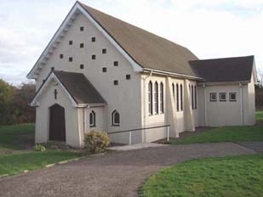

St Anne's, High Cross

St Anne's is one of the smallest of our churches, serving the High Cross area of the parish. Although it is smaller than the congregations at St Basil's and St John's, St Anne's has its own sense of community and its own activities. Each Sunday it holds the 'Time for God' service which attracts all ages to a mix of songs, worship and prayers, and which suits the modern church building well. In 2020 the PCC of the original parish voted to close St Anne’s due to falling numbers and spiralling costs. This hasn’t taken place yet due to the Covid 19- Pandemic.

St Basil the Great, Bassaleg

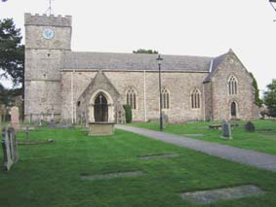
Saint Basil’s is the oldest and one of the largest of the churches. The origins of this beautiful church date back before the 12th century and the Tower and chancel still remain. The rest of the building owes much to the restorers of the Victorian age. The church can Seat around 400 people and is in good condition. The building is situated in a large churchyard which is beautifully maintained by a contractor and supplemented by a group of volunteers. The churchyard is closed to new burials, although there is space for cremated remains.

The 10am Modern language (2004) service is sung with hymns accompanied by the Pipe Organ and small dedicated choir.

St Basil’s has a well-equipped modern church hall built in 2012. This is used by community groups.

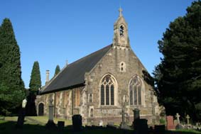

St John the Baptist Rogerstone

St. John’s Church is at the heart of old Rogerstone and was built in 1887. It is a traditional church which seats about 180 people. The font is located at the back of the church and there is also a covered baptistry set into the floor. The main service is a modern language Eucharist on a Sunday at 10.45am supported by an organist and choir. All churches in the benefice have readers, intercessors, sidespeople and Eucharistic assistants.

St John the Baptist, Oakfield Road
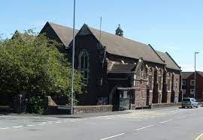

St John Baptist church is on the west side of Newport, a mile to the east of Junction 27 of the M4. Since its beginning in 1875, St John’s has always stood firmly in the Tractarian/Anglo-Catholic tradition. The Holy Eucharist is the heart of our communal life. It is a large church and hosts many concerts throughout the year.
St Martin in the Gaer 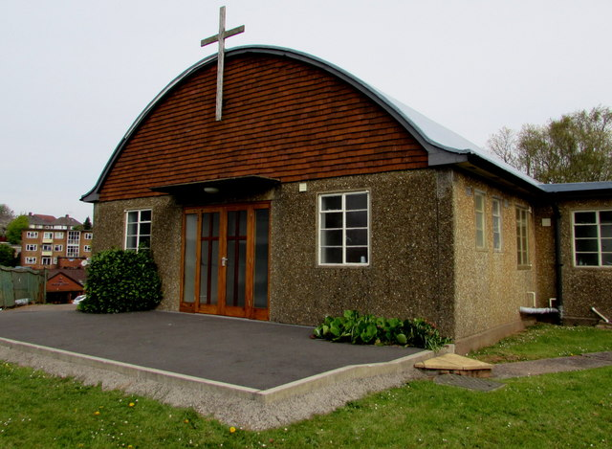

St Martin in the Gaer was built in the late 1950s, intended as a temporary place of worship for the people of the newly-built Gaer Estate. The original church building is still being used and is in good order. A small but dedicated congregation who are keen to support outreach into this part of the Ministry Area

St Thomas Maesglas
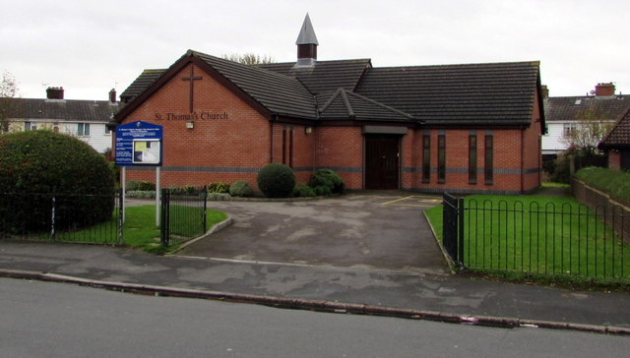
Set back from the south side of Old Cardiff Road, the church is situated in the heart of the community of Maesglas.
This building opened for worship in 2001, replacing a corrugated metal church dating from 1932. The Church is in excellent order with many modern facilities. The congregation are very supportive of each other and work hard to create a friendly community.

Patterns of Worship and attendance
 | Sunday  9.30am | Sunday  10am | Sunday  10.45am | Sunday  11.30am | Monday  7.30pm | Tuesday  10am | Thursday | Friday
St. Annes |  |  |  | 15
St Basil’s |  | 40 |  |  | 6 |  |  | 3
St John’s Oakfield Road |  | 20
St John’s Rogerstone |  |  | 25 |  |  | 10
St Martin’s in the Gaer | 7
St Thomas Maesglas |  |  | 25

Festal, Seasonal, Patronal and Holy Days
We observe the liturgical seasons and have separate service booklets for each prepared from the seasonal material from the Church in Wales.
We observe the Holy Days of Ascension and Corpus Christi with a Eucharist in St Basil’s. We observe All Saints and All Souls Days (where we remember the departed by name).
We greatly value our inclusive, ‘gently catholic’ tradition and aim to offer a safe and supportive spiritual environment for those of all church traditions – and of none. We greatly welcome people who want to explore faith before making a commitment as well as those who are unsure of their beliefs.
What do we need from our new Vicar?
We are looking for a Vicar who will build on what we have already achieved, help us meet these challenges and move to the next phase of our journey. She or he needs to be a person of strong personal faith and leadership skills. But it is essential for the appointee to be a collaborative team player who is able to nurture, motivate and affirm the talents and contributions of others. Spiritually the ideal candidate will be comfortable with a moderate catholic ethos as well as informal and participatory worship. The successful candidate will work alongside the Rector, Assistant Curate, retired Priests and lay ministry team.
The ideal candidate will be a people person, who is not only approachable for those in the existing congregations but also comfortable being out and about in the communities, building connections.
The MA needs someone who is willing to bring their own gifts but also recognise and empower the gifts in others. The candidate who can do this sensitively, compassionately, prayerfully and with humour, will find a warm and exciting new opportunity for ministry.

The Vicarage
The Vicarage is a four bedroom purpose-built home next to St John’s Church in Rogerstone. It comes with ample parking, a pleasant garden, a study and toilet separate from the main house. The MA will reimburse expenses of office, including a telephone line and calls, a broadband connection and a quarter of heating and lighting costs.

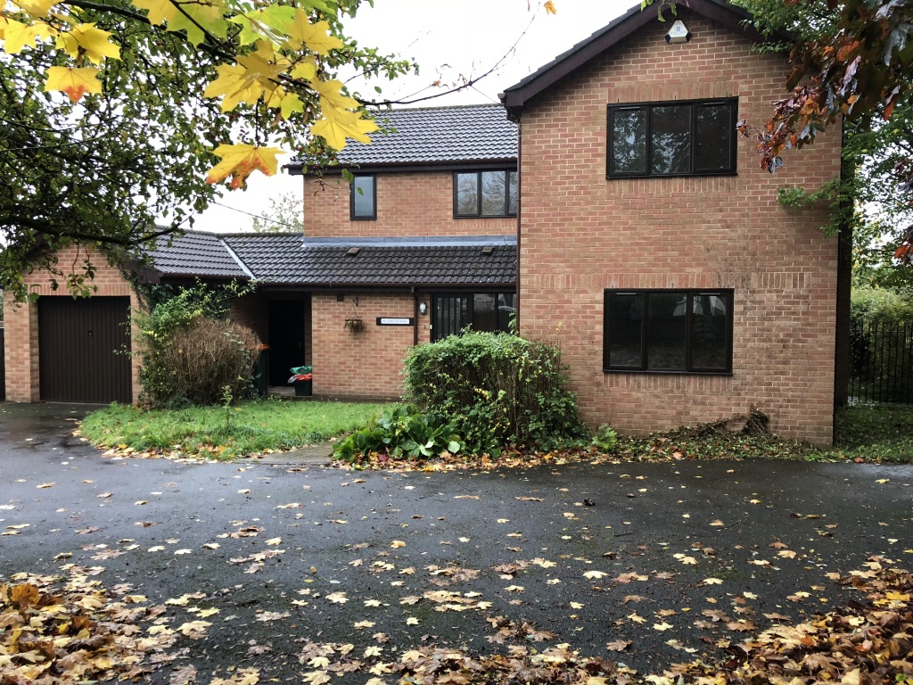
We expect the Vicar to take one day off each week, to take a full holiday entitlement of four weeks, Plus the inside of the week after Christmas and Easter. We will also encourage you to take an annual retreat.

If you would like an informal conversation about this post then please contact the Revd Chris Stone on 01633 378354.

The closing date for applications is Friday 8th July 2022. Please email your completed application form to the Venerable Jonathan Williams at jonathanwilliams@cinw.org.uk.

Appendix

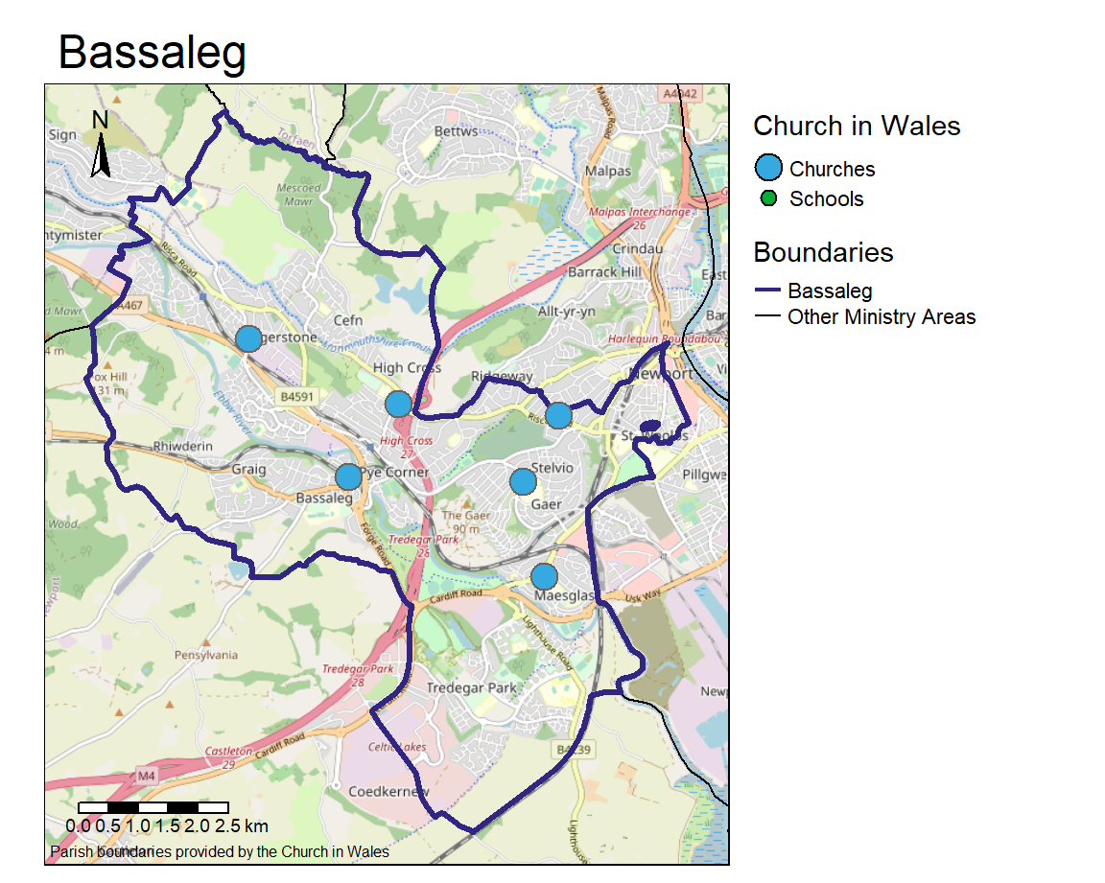

If the Ministry Area were a village of 100 people…
- 14 would be school-aged (aged 5-15), compared with
  - 13 in the Diocese of Monmouth; 12 in Wales,
- 17 would be aged 65 or over,
  - 17 in the Diocese of Monmouth; 18 in Wales,
- 60 would be Christian,
  - 55 in the Diocese of Monmouth; 58 in Wales,
- 29 would have no religion,
  - 34 in the Diocese of Monmouth; 32 in Wales,
- 23 would have no qualifications,
  - 28 in the Diocese of Monmouth; 26 in Wales,
- 34 would have higher education qualifications,
  - 27 in the Diocese of Monmouth; 29 in Wales,
- 7 would be over 16 and in full-time education,
  - 7 in the Diocese of Monmouth; 8 in Wales,
- 14 would have some skills in Welsh,
  - 13 in the Diocese of Monmouth; 27 in Wales,
- including 7 who could speak, read and write Welsh,
  - 7 in the Diocese of Monmouth; 15 in Wales.
If the Ministry Area were a village with 100 households…
- 76 would have access to a car or van, compared with
  - 76 in the Diocese of Monmouth; 77 in Wales,
- 31 would be renting their home,
  - 32 in the Diocese of Monmouth; 31 in Wales,
- including 13 who would be renting from private landlords,
  - 12 in the Diocese of Monmouth; 14 in Wales,
- 31 would be made up of 1 person,
  - 29 in the Diocese of Monmouth; 31 in Wales,
- including 14 who would be aged over 65,
  - 13 in the Diocese of Monmouth; 14 in Wales,
- 31 would have children in the household,
  - 31 in the Diocese of Monmouth; 28 in Wales,
- including 8 who would have lone parents,
  - 9 in the Diocese of Monmouth; 8 in Wales.
- 