Church Building Re-opening Grant

Please refer to the Covid-19 Guidance provided by the Church in Wales for more information and full requirements for re-opening church buildings.
https://www.churchinwales.org.uk/en/clergy-and-members/coronavirus-covid-19-guidance/

General Criteria
Applications must be supported by the Incumbent and Warden(s) and endorsed by your Archdeacon.

Eligible Costs:

Hand Sanitiser, soap, cleaning spray and cloths, hazard tape and/or barrier rope, appropriate PPE etc.

One trusted and reliable source for your supplies is Parish Buying. If you wish to use Parish Buying we recommend registering with them and their suppliers now as it can take a few days to verify your account.
https://www.parishbuying.org.uk/index.php/categories/covid-19-supplies

Grant Information

- Please return this form to Libby Morgan-Owen.
monmouthadministration@churchinwales.org.uk
- Each church could receive a maximum of £100.
- Any grant offer made will automatically lapse if not taken up within 3 months.

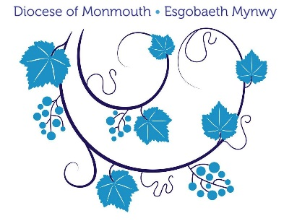

GRANTS FOR THE REOPENING OF CHURCHES

Ministry Area/Parish:

Which churches are you applying for?

Applicant Details

Name –

Role held -

E-mail address -

Telephone number –

Date –

1. | Have you completed a Covid-19 Risk Assessment for each church and has it been signed off by your Archdeacon?

2. | What supplies do you need to purchase to re-open safely?

3. | Estimated costs breakdown

4. | Is the Ministry Area/Church able to fund any of these costs?

6. | Any other notes or information (a supplementary sheet may be used if necessary)

7. | Archdeacon Endorsement: Date:

For further information please contact Libby Morgan-Owen,
monmouthadministration@churchinwales.org.uk
07508 801511

______________________________

